**PROJECT REPORT**

**ON**

**“Tour & Travel Website”**



***Submitted  by -***

**Manu Pachauri(201500387)**

**Tanishq Gupta(201500736)**

***in partial fulfillment for the award of the degree of***

#### BACHELOR OF ENGINEERING

**IN**

##### Computer Engineering and Application

**GLA University, Mathura**

**NOVEMBER** **2022**

**Department of Computer Engineering & Applications**

**Institute of Engineering & Technology**

**GLA University**

**Mathura- 281406, INDIA**

Department of Computer Engineering and Applications GLA University, Mathura

**17 km. Stone NH#2, Mathura-Delhi Road, P.O. –**

#### BONAFIDE CERTIFICATE

Certified that this project report “**Tour and Travel Website”** is the bonafide work of **“Tanishq Gupta and Manu Pachauri”** who carried out the project work under my Supervison.

Signature of HOD Signature of Mentor

Name of HOD - Dr. Rohit Agrawal Name of Mentor - Ms. Gurpreet Kaur(Technical Trainer)

Department - Computer Science & Engineering Department - Computer Science & Engineering

Submitted for the project viva examination held on 22 November 2022.

**INTERNAL EXAMINER EXTERNAL EXAMINER**

### **DECLARATION**

We hereby declare that the work which is being presented in the Project Report **“Tour & Travel Website”,** in partial fulfillment of the requirements for Project is an authentic record of our own work carried under the Mentorship of **Ms. Gurpreet Kaur, Technical Trainer, GLA University, Mathura**.

|  |  |
| --- | --- |
| Name of Candidate: | University Roll No.: |
| Tanishq Gupta | 201500736 |
| Manu Pachauri | 201500387 |

### TABLE OF CONTENTS



Certificate

#### 1. Introduction 4

#### 2. Hardware and Software Requirements 5

#### 3. Methodology 6

#### 4. Results 8-10

#### 5. Conclusion 11

**Introduction**

The Tours and Travel Website is a web based application. The main purpose of “Tours and travel website ” is to provide a convenient way for a customer to book hotels, flight, train and Trips for tour purposes. The objective of this project is to develop a system that automates the processes and activities of a travel agency. In this project, We will make an easier task of searching places and for booking train, flight or bus. . In the present system a customer has to approach various agencies to find details of places and to book tickets. this often requires a lot of time and effort. We provide approach skills to critically examine how a tourist visits and its ability to operate in an appropriate way when dealing with the consequences of tourism, locally, regionally, and nationally including visitor security and ecological influences. It is tedious for a customer to plan a particular journey and have it executed properly. The project ‘Tours and Travel Website’ is developed to replace the currently existing system, which helps in keeping records of the customer details of destination as well as payment received.

**Hardware and Software Requirement**

#### H/W System Configuration: -

System: Intel Core i3-5005U (5th Gen)

Hard Disk: 1 TB.

Monitor: Standard LED Monitor

Input Devices: Keyboard

Ram: 8 GB

#### S/W System Configuration:-

Operating system: Windows 10

Coding Language: HTML,CSS,JAVASCRIPT

Database: Visual Studio Code

Project Name : Tour & Travel Website

**Result**

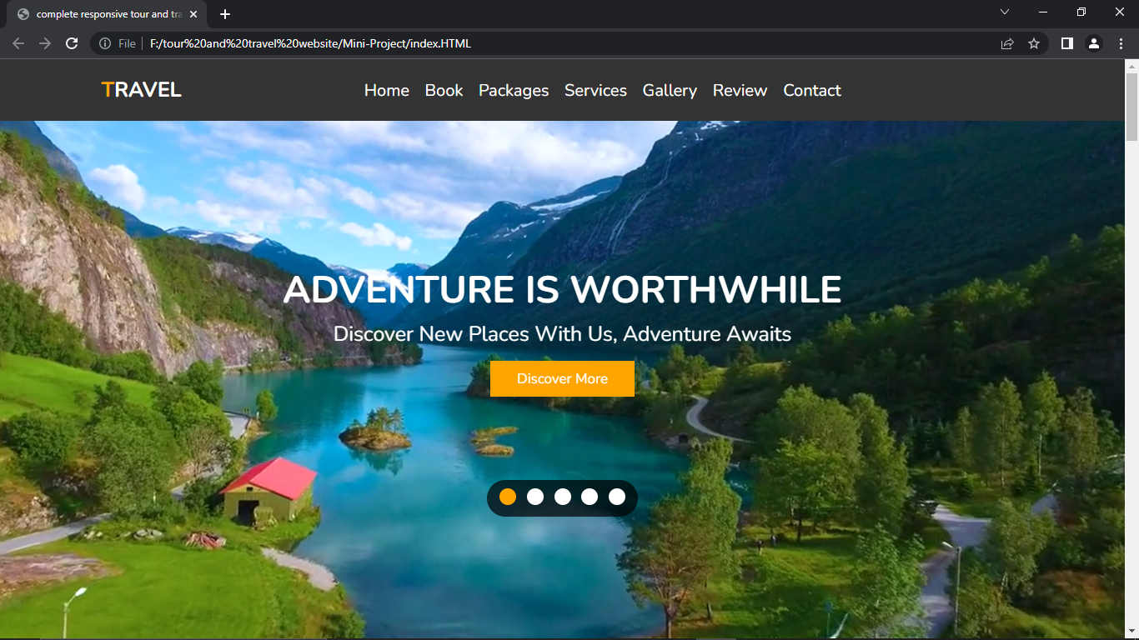

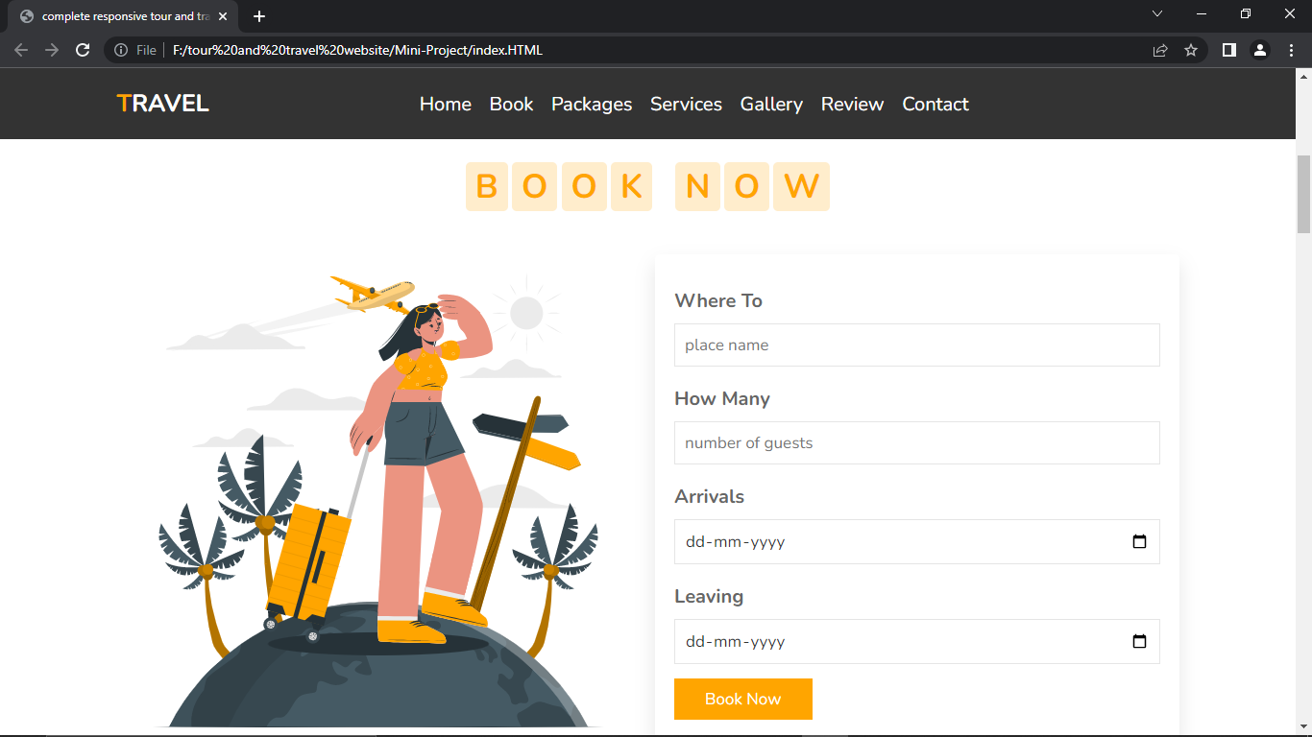

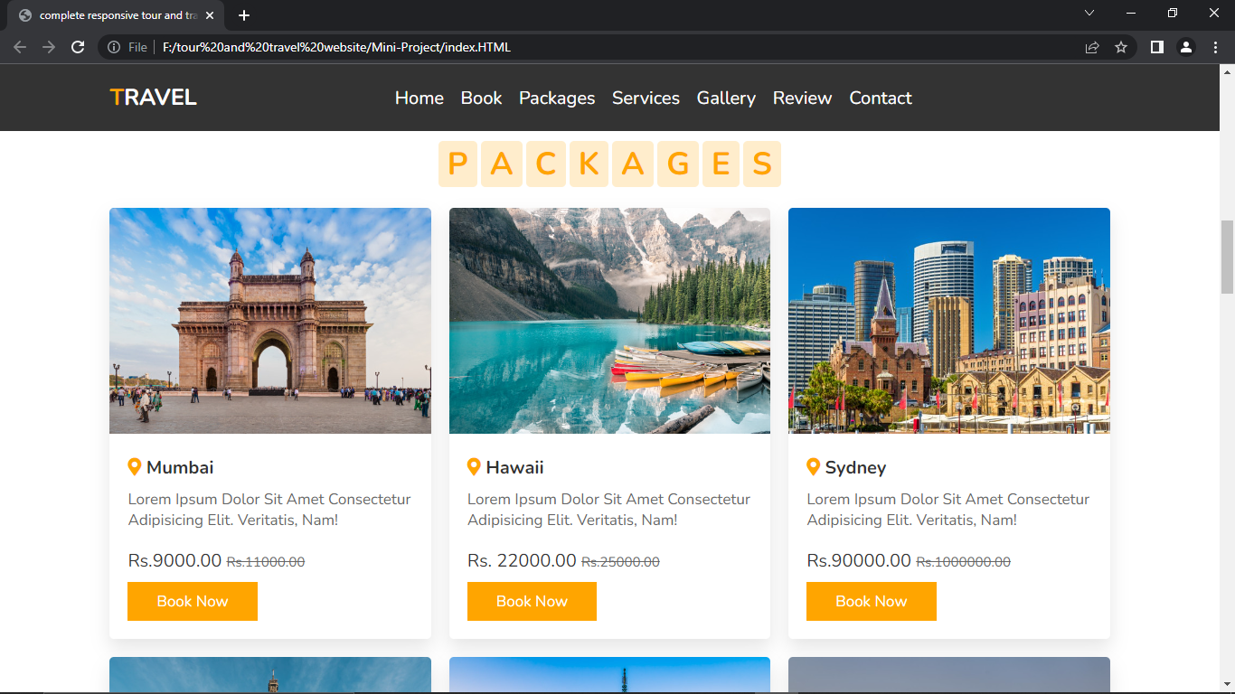

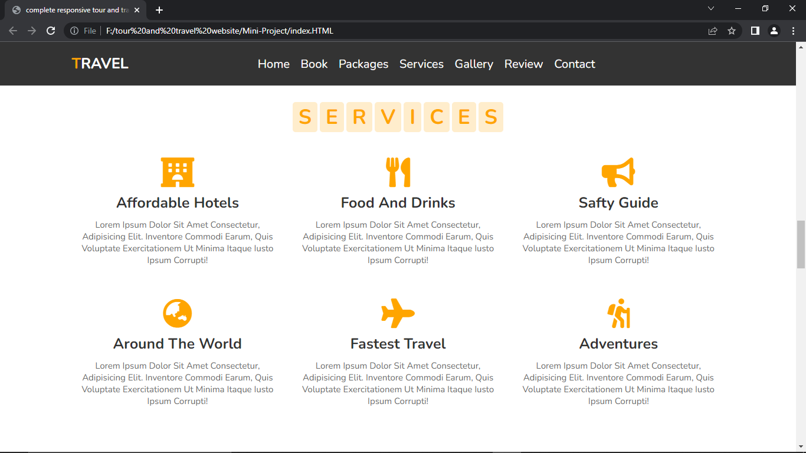

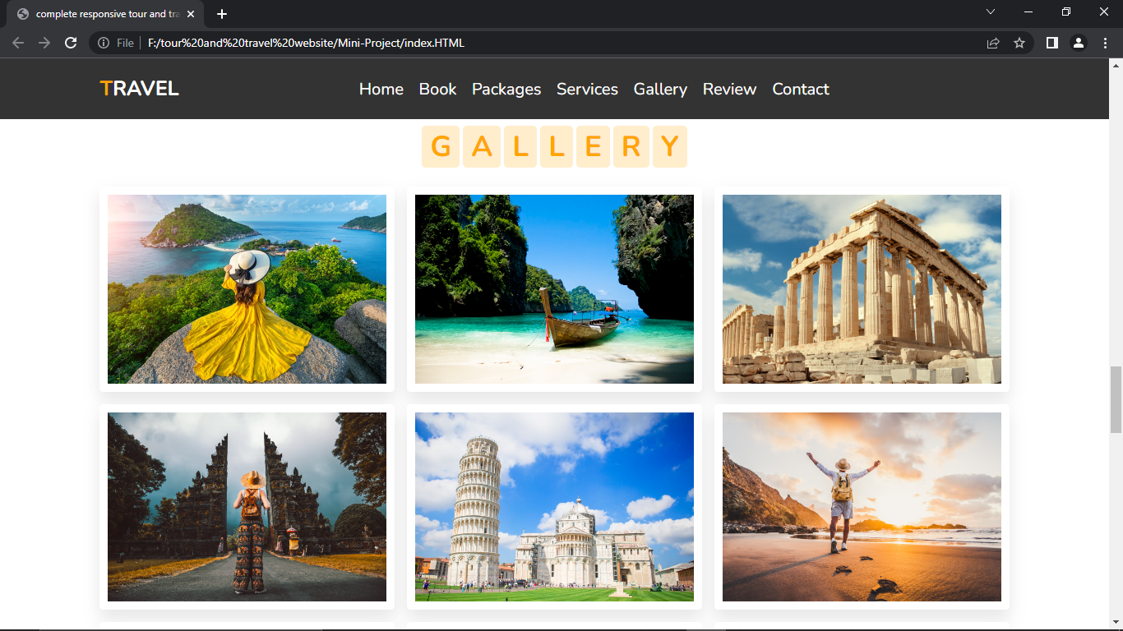

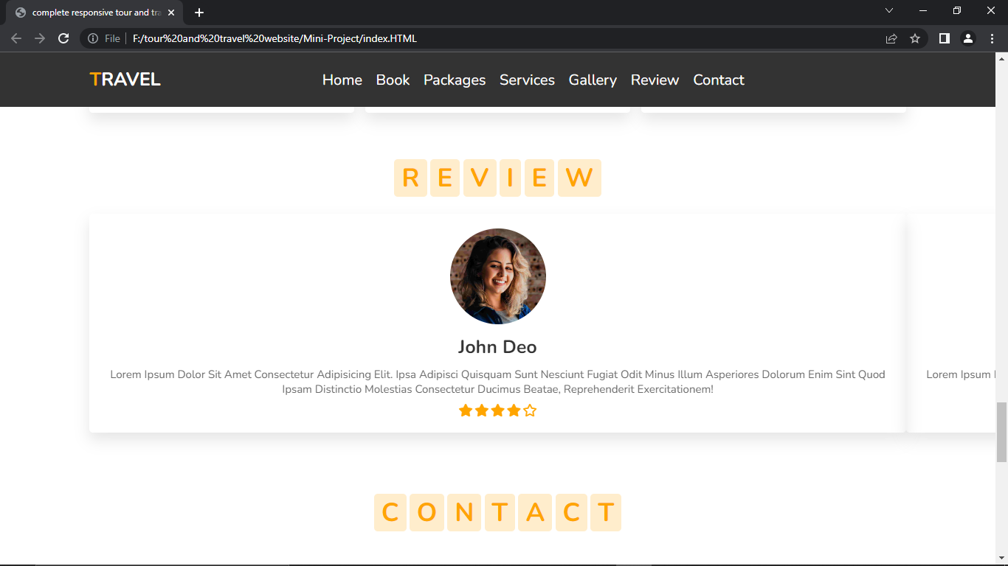

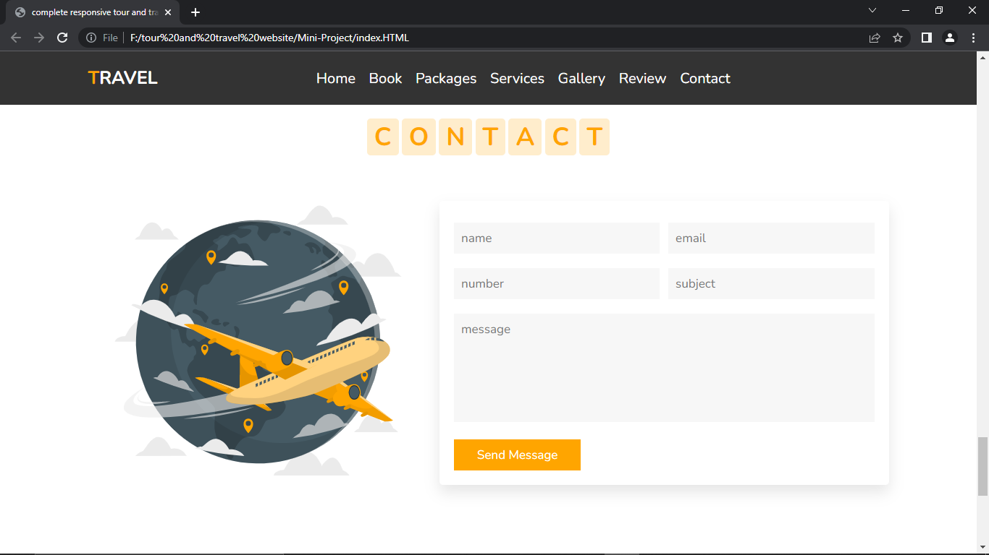

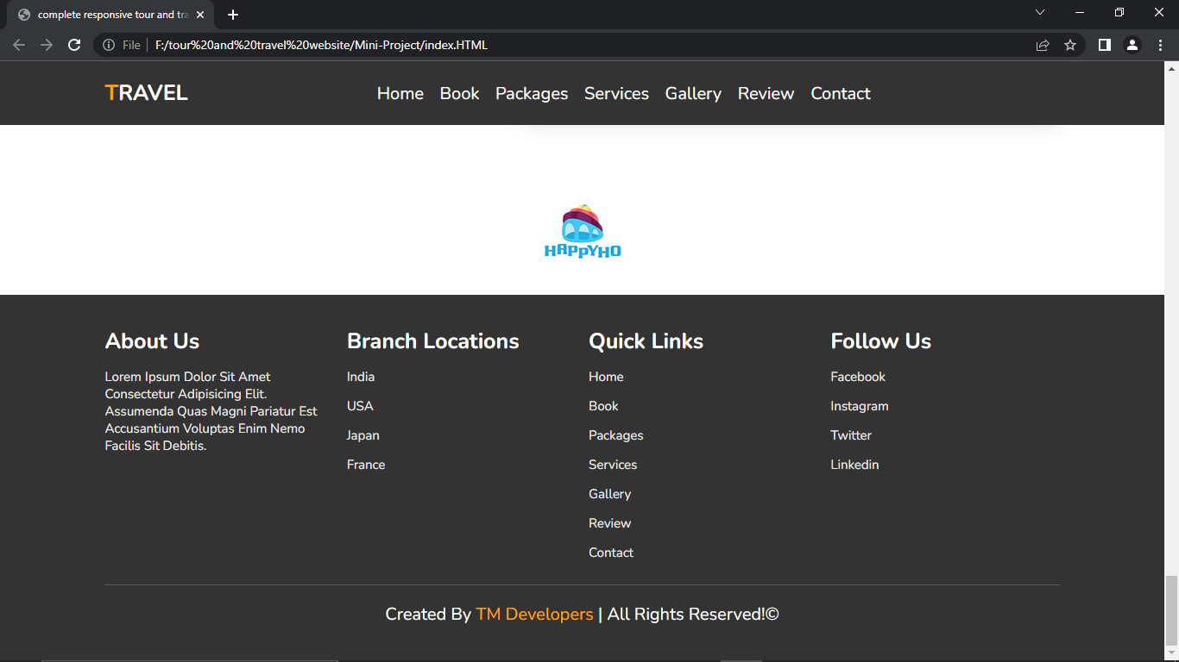

**CONCLUSION:**

# The Tour & Travel website has been implemented successfully by using visual studio code. And the language used is HTML,CSS,JavaScript. This site is used to book Trips.

* + An information system's development has been presented.
  + As a future work, some additional stuff could be implemented and back-end server integrated into this site making it much more reliable,optimize and flexible.